### How to create Branch and push to github

Step 1: checkout to branch master and git pull to update a new changes

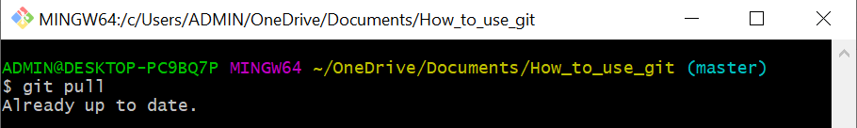

Step 2: create a new branch and checkout it

There are 2 ways to do it

Way 1: By using the following commands:

+ git branch <branch name>: create a new branch

+ git branch: to know what is the current branch and amount of branches

+ git checkout <branch name>: checkout to the branch which you want to switch

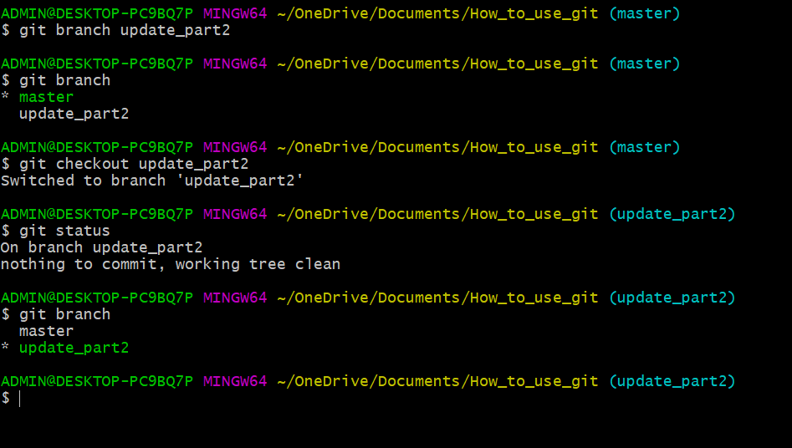

Way 2: create and checkout branch in parallel

+ git checkout –b <branch name>

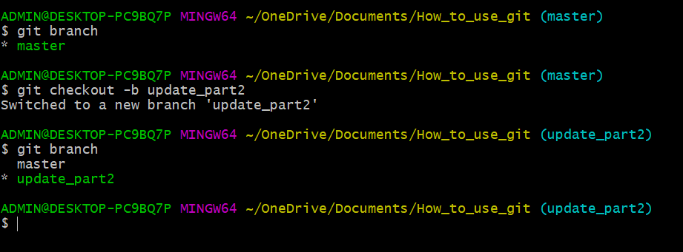

Step 3: Check the status of file by using git status

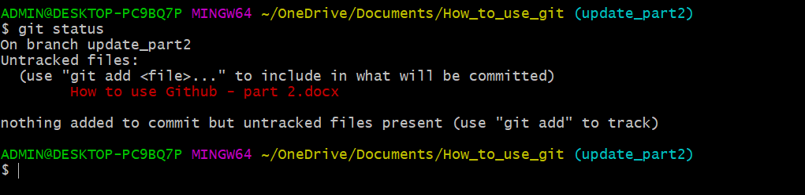

Step 4: Add files by using the following commands:

+ git add .

+ git add <file names>

Step 5: Commit files by using git commit –m “<any message…..>”

Step 6: Push file to github by using git push origin <branch name>

In this example is git push origin update_part2

Step 7: Then create pull request for this branch

In this example is create pull request from update_part2 to master

Step 8: Merge pull request to branch master